80gsm Sticky(Adhensive) Sublimation Paper for Elastic Fabric Printing

Item Code:Features:80gsm sticky back sublimation transfer paper, it can suit for Lacra, Polyester, and Polyester with Spandex textile.
- Description
80gsm Sticky(Adhensive) Sublimation Paper for Elastic Fabric Printing
Characteristics
80gsm sticky back sublimation transfer paper, it can suit for Lacra, Polyester, and Polyester with Spandex textile. Especially designed for elastic textiles, no movemenrt between paper and fabric during transfer. The leval of tack depends on the fabric in use. Prior testing is required.
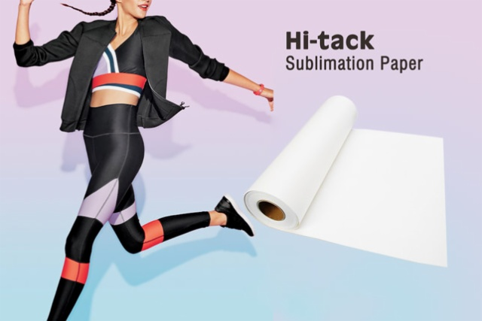
Advantages
(1. Sharp text and fine lines as there is no movement between paper and fabric
(2. Enhanced tack-effect to work with a wide range of spandex textiles.
(3. Maximum reduction of textile shrinkage can be achieved.
(4. No ghosting.
(5. Excellent stability and performance.

Applications
Suit for elastic textiles apparel such as lycra materials, swim and surfwear, cycling, running and ice hockey wear.

Suitable ink systems
Water-based sublimation
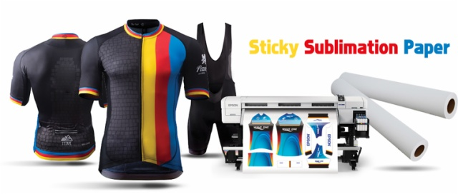
Availablility
Width | Length | Core | Qty Rolls/Pallet
432mm/17inch | 100m/328ft/109yds | 2inch/3inch | 84
610mm/24inch | 100m/328ft/109yds | 2inch/3inch | 84
914mm/36inch | 100m/328ft/109yds | 2inch/3inch | 42
1,118mm/44inch | 100m/328ft/109yds | 2inch/3inch | 42
1,270mm/50inch | 100m/328ft/109yds | 2inch/3inch | 42
1,320mm/52inch | 100m/328ft/109yds | 2inch/3inch | 42
1,370mm/54inch | 100m/328ft/109yds | 2inch/3inch | 42
1,524mm/60inch | 100m/328ft/109yds | 2inch/3inch | 42
1,600mm/63inch | 100m/328ft/109yds | 2inch/3inch | 42
1,620mm/64inch | 100m/328ft/109yds | 2inch/3inch | 42
1,820mm/72inch | 100m/328ft/109yds | 2inch/3inch | 42
1,900mm/74inch | 100m/328ft/109yds | 2inch/3inch | 42
2,400mm/94inch | 100m/328ft/109yds | 2inch/3inch | 30
2500mm/98inch | 100m/328ft/109yds | 2inch/3inch | 30
2600mm/102inch | 100m/328ft/109yds | 2inch/3inch | 30
3200mm/126inch | 100m/328ft/109yds | 2inch/3inch | 30
Other widths upto 3.2m and jumbo reel sizes available upon request.

Indoor Condition in Printing Room or Workshop:
Humidity: 40-60% (not more than 60%)
Temperature: 78.8℉ / 26℃

Testing Condition:
Ink-load: 400%
Transfer Temperature: 200-230℃
Transfer Time: 20-30 seconds
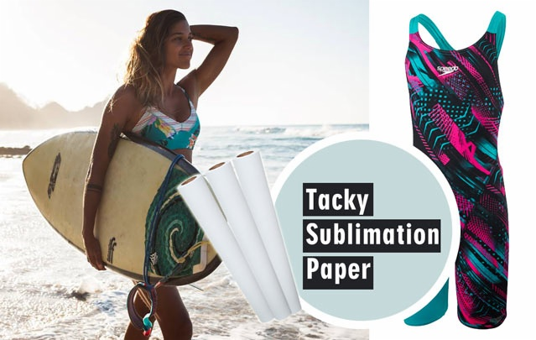
About storage:
In order to protect unused sublimation paper, it is recommended to store it in its original packaging, in the poly bag at 68°F -82°F( 20°C -28°C) and 40-60% RH.

About printing:
Image side is wound to the outside of the paper. Printing is performed in ″mirror″ image. Allow the printing ink to dry before transferring.
Width | Length | Core | Qty Rolls/Pallet
432mm/17inch | 100m/328ft/109yds | 2inch/3inch | 84
610mm/24inch | 100m/328ft/109yds | 2inch/3inch | 84
914mm/36inch | 100m/328ft/109yds | 2inch/3inch | 42
1,118mm/44inch | 100m/328ft/109yds | 2inch/3inch | 42
1,270mm/50inch | 100m/328ft/109yds | 2inch/3inch | 42
1,320mm/52inch | 100m/328ft/109yds | 2inch/3inch | 42
1,370mm/54inch | 100m/328ft/109yds | 2inch/3inch | 42
1,524mm/60inch | 100m/328ft/109yds | 2inch/3inch | 42
1,600mm/63inch | 100m/328ft/109yds | 2inch/3inch | 42
1,620mm/64inch | 100m/328ft/109yds | 2inch/3inch | 42
1,820mm/72inch | 100m/328ft/109yds | 2inch/3inch | 42
1,900mm/74inch | 100m/328ft/109yds | 2inch/3inch | 42
2,400mm/94inch | 100m/328ft/109yds | 2inch/3inch | 30
2500mm/98inch | 100m/328ft/109yds | 2inch/3inch | 30
2600mm/102inch | 100m/328ft/109yds | 2inch/3inch | 30
3200mm/126inch | 100m/328ft/109yds | 2inch/3inch | 30
Other widths upto 3.2m and jumbo reel sizes available upon request.
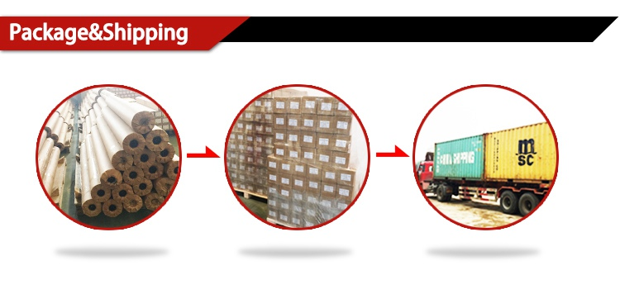
Our Services
1. We offer OEM/ODM Service.
2. We are integrated industrial and trade enterprises. We can offer the best international trading service.
3. We have been producing since 2009. Quality is the reason why we can stand on the top of industry, we can always give you the best quality control.
4. Fast delivery. We have plenteous production lines and scientific production management system to ensure the delivery time.
5. We have professional team working for overseas trading, which can save more of your valuable time.﻿

About Our Company
We have complete confidence to offer you high quality, to satisfy well with your requirements
1. 10 years experience of printer consumables production in China.
2. Top quality material we import from Germany
3. Strict quality controlling and professional QC inspecting before shipping
4. Factory directly supply, all made by ourselves, save much cost for you.
5. High quality and best services
6. OEM/ODM orders are acceptable

1,What is your time of making samples?
Usually we will take around 3-7 days to make the samples.

2,What is your MOQ?
Our MOQ is 50 rolls sublimation paper

3,What is your delivery time?
The time of delivery is about 10-30 days.

4,What is the loading port?
Ningbo, Shenzhen, Guangzhou and Shanghai are available.

5,What is your payment terms?
We accept T/T, Paypal, Western Union, Moneygram, etc.

6,What is your main products?
Our main products are Sublimation Transfer Paper, T Shirts Transfer Paper, Sublimation Inks and other sublimation Blanks and Equipments.

7, What's the shipping way?
Via DHL, FedEx, EMS, UPS, by air, by sea...etc. As you required.

8,Do you have after-sales service?
Yes. If you have any problems, you can chat online or send email to us.

1. Strict Quality Control: We have over 10 workers cooperating on Quality control both for the original Material and finished Goods. QC before delivery is also what we need for each order.

2. One stop Solution: We offer a wide range of sublimation paper, dye sublimation ink and Blanks. Making you able to source all the items you need.

3. Reasonable Pricing: We run our own coating factory and Heat Press Machine assembling Workshop, thus to offer the most reasonable pricing and give the most profit to our clients.

4. Fast Delivery: We offer one week delivery for most paper orders. And 2-3 weeks production lead time for other sublimation inks.
﻿﻿
5. Responsible after sale service: As a responsible company, we never make any exercise for mistakes, clients comes first, any complaint is supposed to be settled in a responsible manners.

