Double working platform LED strip light soldering machine
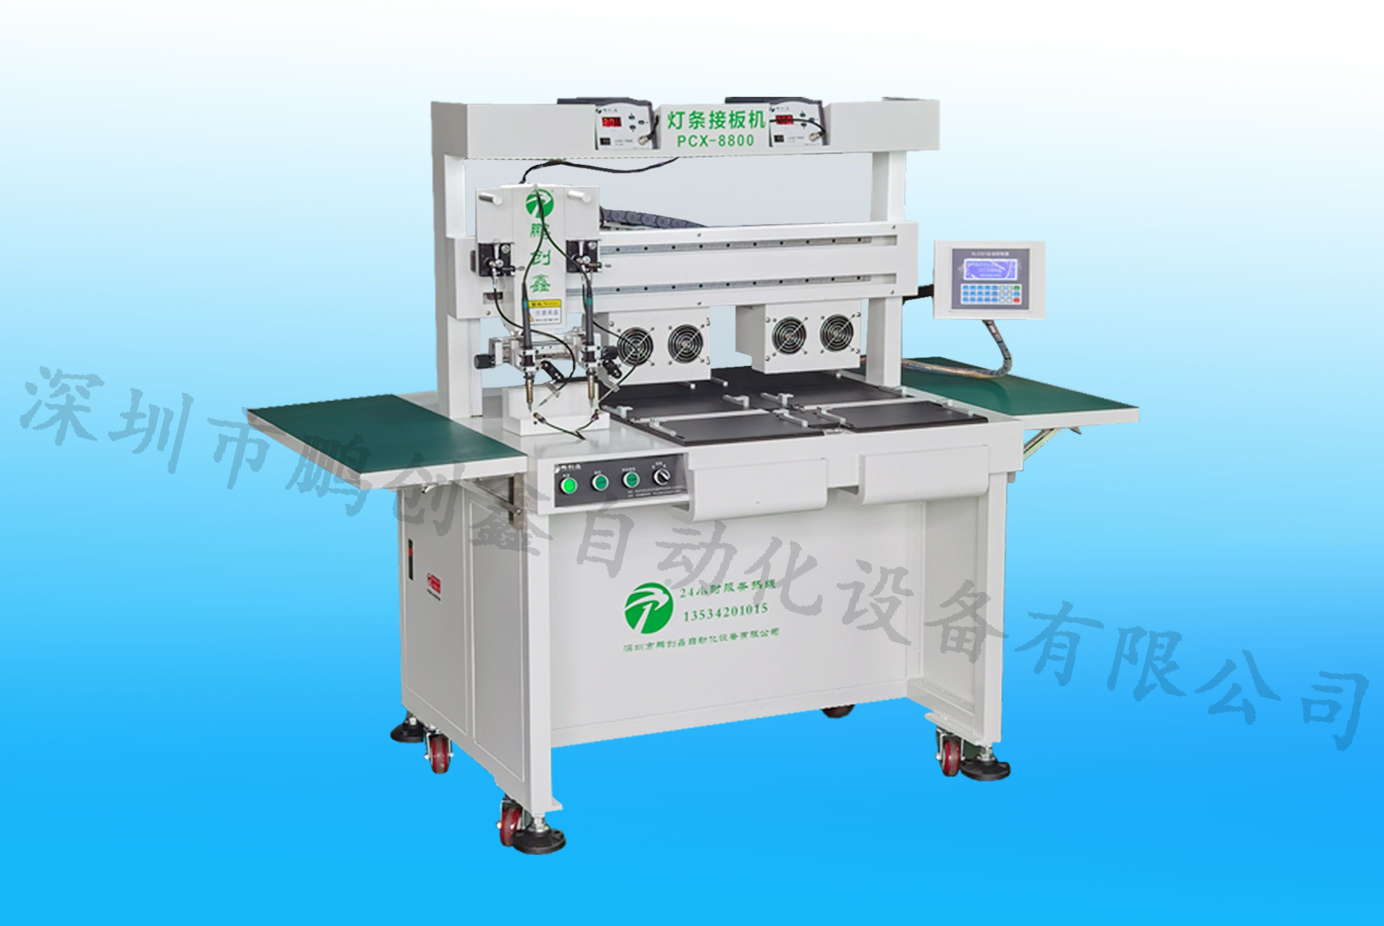

One,Product Brief：

PCX-8800 is a dual working platform LED strip light soldering machine,It is a dedicated automatic welding equipment for 5 meter LED strip welding,According to the characteristics of LED equipment 5 meters depth of humanization design, engaged in a variety of different solder joints instead of manual soldering work, solve the manual welding of weld solder joint is not uniform, and other phenomena, and compatible with a variety of types of LED soft strip size of welding, simple operation and high practicability, quality stability, greatly enhance the efficiency.
First, product advantages:
- Simple programming, operation control box mobile head position.
- Welding speed, high efficiency, a solder machine can save 5-6 people
- Save tin wire, good consistency of solder joint
- High power heating controller ensures the stability of continuous welding
The utility model relates to a double head fine tuning welding gun structure, which is convenient for regulating the welding torch spacing and synchronous operation
- Multi axis manipulator, advanced motion control algorithm, to improve the kinematic positioning accuracy and repeatability accuracy
- According to the professional design of the lamp batten, it is convenient for manual feeding and feeding
- Production efficiency: 2000-2500 meters /H.
- It can replace the manual process and optimize the quality control.
- Improve efficiency, save manpower, simple operation, new staff can achieve the welding effect of skilled workers

Two, scope of application:
LED soft light plate soldering machine application range: suitable for LED monochromatic light, 5050RGB lamp string, lamp belt, lamp strip and other products

Three, technical parameters:
NO. | Item | parameter
1 | Device name | LED soft strip light soldering machine-Dual working platform
2 | Model | PCX-8800
3 | control mode | 32position DSP
4 | Welding head | 2 iron heads work at the same time
5 | Work platform | 2 working platforms
6 | Working stroke | X axis 350MM，Z axis 150MM,platform 1000MM
7 | Repeatability accuracy | ±0.05mm
8 | Equipment power | 600w
9 | Power Supply | 220V,50-60HZ
10 | weight | 120KG
11 | Size | 1600*1200*1400（Length*width*height）

Technical parameter configuration:

Automatic soldering machine configuration
NO | Name | brand
1 | Control system | independent research and development
2 | Motor | High precision motor
3 | Guide | Taiwan PMI
4 | sensor | Japan：OMRON
5 | Pneumatic components | Air TAC
6 | Power Supply | Meanwell
7 | Welding gun heating mode | High frequency custom welding table
8 | Drive mode | Japan Misumi industrial belt

