120gsm High Weight Sublimation Paper for Digital Printing

Features:(1. Instant-dry with extra-high ink absorption capacity (2. Excellent durability and outstanding efficiency (3. No color strike-through (4. Superb and quick transfer properties (5. Outstanding lay-flat performance (6. Recommended for designs with dark, saturated colors or high ink loads

- Description
120gsm High Weight Sublimation Paper for Digital Printing
Characteristics:
Transfer on all kinds of polyester coated hard substrates polyester textiles. Especially designed for sublimation onto fabrics used in sportswear and soft signage, and display market with optimised barrier properties. Very high ink coverage and deep colour possible.
Advantages:
(1. Instant-dry with extra-high ink absorption capacity
(2. Excellent durability and outstanding efficiency
(3. No colour strike-through
(4. Superb and quick transfer properties
(5. Outstanding lay-flat performance
(6. Recommended for designs with dark, saturated colours or high ink loads
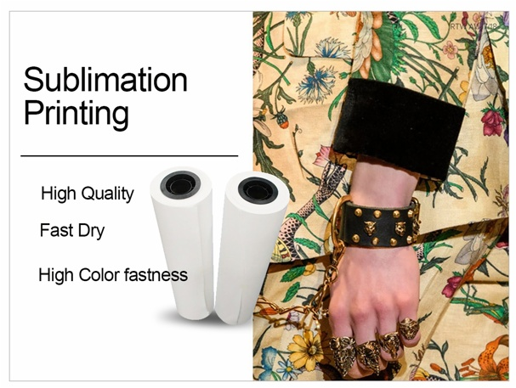

Applications:

*Apparel
- Lycra materials-cycling
- Polyamide-Swim&Surfwear
- 100% polyester(stretch)-cycling, running, ice hockey wear
- Sports and functional textiles
*Home Internal:
Curtain, Blind, Cushion, Table Cover, Towel Cleaner, etc.
*Advertisement
- Flags
- Banners
- Felts
- Gaming tables
- Home Textiles
*Hard Substrates
- Ceramics
- Metal plates
- Skis
- Snowboards
- Mug, Cup

Availablility:
Width | Length | Core | Qty Rolls/Pallet
432mm/17inch | 100m/328ft/109yds | 2inch/3inch | 84
610mm/24inch | 100m/328ft/109yds | 2inch/3inch | 84
914mm/36inch | 100m/328ft/109yds | 2inch/3inch | 42
1,118mm/44inch | 100m/328ft/109yds | 2inch/3inch | 42
1,270mm/50inch | 100m/328ft/109yds | 2inch/3inch | 42
1,320mm/52inch | 100m/328ft/109yds | 2inch/3inch | 42
1,370mm/54inch | 100m/328ft/109yds | 2inch/3inch | 42
1,524mm/60inch | 100m/328ft/109yds | 2inch/3inch | 42
1,600mm/63inch | 100m/328ft/109yds | 2inch/3inch | 42
1,620mm/64inch | 100m/328ft/109yds | 2inch/3inch | 42
1,820mm/72inch | 100m/328ft/109yds | 2inch/3inch | 42
1,900mm/74inch | 100m/328ft/109yds | 2inch/3inch | 42
2,400mm/94inch | 100m/328ft/109yds | 2inch/3inch | 30
2500mm/98inch | 100m/328ft/109yds | 2inch/3inch | 30
2600mm/102inch | 100m/328ft/109yds | 2inch/3inch | 30
3200mm/126inch | 100m/328ft/109yds | 2inch/3inch | 30
Other widths upto 3.2m and jumbo reel sizes available upon request.
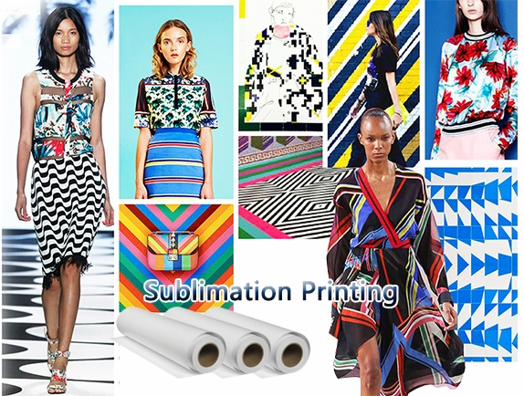

Indoor Condition in Printing Room or Workshop:
Humidity: 40-60% (not more than 60%)
Temperature: 78.8℉ / 26℃

Testing Condition:
Ink-load: 400%
Transfer Temperature: 200-230℃
Transfer Time: 20-30 seconds

About storage:
In order to protect unused sublimation paper, it is recommended to store it in its original packaging, in the poly bag at 68°F -82°F( 20°C -28°C) and 40-60% RH.
About printing:
Image side is wound to the outside of the paper. Printing is performed in ″mirror″ image. Allow the printing ink to dry before transferring.

OEM:
We accept the oem, you only need give us your design:
1). Put your LOGO on the pack side of the paper.
2). Provide the package ( OPP and box) with your brand.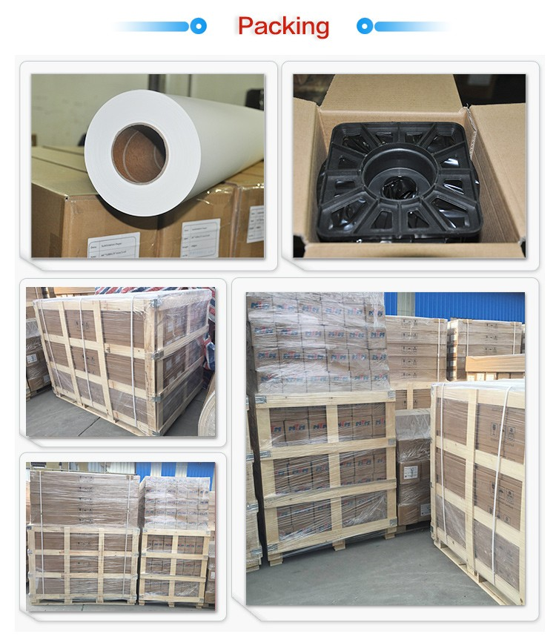

About Our Company
We have complete confidence to offer you high quality, to satisfy well with your requirements.
1.10 years experience of printer consumables production in China.
2. Top quality material we import from Germany
3. Strict quality controlling and professional QC inspecting before shipping
4. Factory directly supply, all made by ourselves, save much cost for you.
5. High quality and best services
6. OEM/ODM orders are acceptable
1,What is your time of making samples?
Usually we will take around 3-7 days to make the samples.
2,What is your MOQ?
Our MOQ is 50 rolls sublimation paper
3,What is your delivery time?
The time of delivery is about 10-30 days.
4,What is the loading port?
Ningbo, Shenzhen, Guangzhou and Shanghai are available.
5,What is your payment terms?
We accept T/T, Paypal, Western Union, Moneygram, etc.
6,What is your main products?
Our main products are Sublimation Transfer Paper, T Shirts Transfer Paper, Sublimation Inks and other sublimation Blanks and Equipments.
7, what's the shipping way?
Via DHL, FedEx, EMS, UPS, by air, by sea...etc. As you required.
8,Do you have after-sales service?
Yes. If you have any problems, you can chat online or send email to us.
1. Strict Quality Control: We have over 10 workers cooperating on Quality control both for the original Material and finished Goods. QC before delivery is also what we need for each order.
2. One stop Solution: We offer a wide range of sublimation paper, dye sublimation ink and Blanks. Making you able to source all the items you need.
3. Reasonable Pricing: We run our own coating factory and Heat Press Machine assembling Workshop, thus to offer the most reasonable pricing and give the most profit to our clients.
4. Fast Delivery: We offer one week delivery for most paper orders. And 2-3 weeks production lead time for other sublimation inks.
5. Responsible after sale service: As a responsible company, we never make any exercise for mistakes, clients comes first, any complaint is supposed to be settled in a responsible manner.

