Technical Parameter Report

Count :20s/2  Raw Material: Yizheng bright(1.33dtex×38mm)  Weight:59.05  Strength:2300CN  Elongation%: 15.55  TPM:580 | Count :20s/3  Raw Material: Yizheng bright(1.33dtex×38mm)  Weight:88.58  Strength:3400CN  Elongation%: 13.909  TPM:460
Count :30s/2  Raw Material: Yizheng bright(1.33dtex×38mm)  Weight:39.37  Strength:1500CN  Elongation%: 14.22  TPM:650 | Count :30s/3  Raw Material: Yizheng bright(1.33dtex×38mm)  Weight:59.05  Strength:2200CN  Elongation%: 14.772  TPM:570
Count :40s/2  Raw Material: Yizheng bright(1.33dtex×38mm)  Weight:29.53  Strength:1100CN  Elongation%: 14.04  TPM:800 | Count :40s/3  Raw Material: Yizheng bright(1.33dtex×38mm)  Weight:44.29  Strength:1700CN  Elongation%: 14.464  TPM:650
Count :50s/2  Raw Material: Yizheng bright(1.33dtex×38mm)  Weight:23.62  Strength:860CN  Elongation%: 13.1  TPM:850 | Count :50s/3  Raw Material: Yizheng bright(1.33dtex×38mm)  Weight:35.43  Strength:1350CN  Elongation%: 11.732  TPM:750
Count :60s/2  Raw Material: Yizheng bright(1.33dtex×38mm)  Weight:19.68  Strength:700CN  Elongation%: 13.47  TPM:900 | Count :60s/3  Raw Material: Yizheng bright(1.33dtex×38mm)  Weight:29.52  Strength:1150CN  Elongation%: 11.584  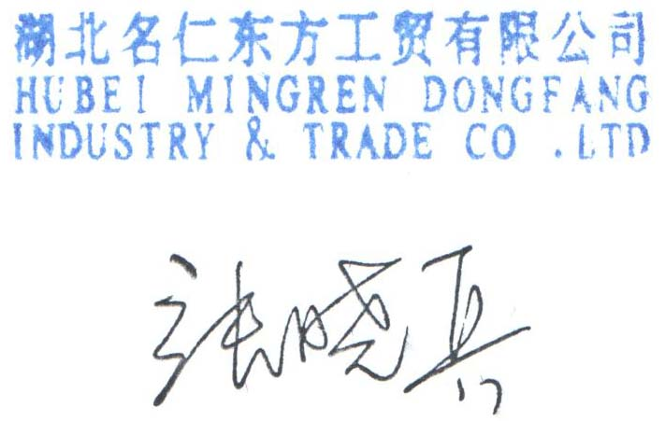  TPM:820

Hubei Mingren Dongfang Industry & Trade Co., Ltd.
Room1402,Block 5 ,Fanhai International CBD,No.62 Zhujiang Road ,Wuhan,Hubei,

