Top Grade Economy 80gsm Sublimation Transfer Paper for Home Textile

Features:(1. It is not suitable to transfer the dark garments and ceramic... (2. It can be used to transfer 100% polyester fabric, coating ceramic, iron plant and wood. (3. Do keep the surface of the object clear (4. Do not operate with the laser printer and the printer in pigment ink, like HP and CANNON printer. (5. It must use the sublimation ink. (6. The best transferring time is 10-15 minutes after printing

High quality sublimation Paper Heat Transfer Printing Paper
Characteristics:
(1. Transfer times and/or temperatures can be reduced significantly and still achieve the same vibrant colours any product is standing for.
(2. Suits for fabric, metal, bag, clothing by sublimation dye ink with inkjet printer.
(3. It offers outstanding durability and actually softens when stretched after application to the fabric.
(4. Especially designed for fabrics used in sportswear and soft signage, with optimized barrier properties.
(5. Suitable for medium to high ink coverage.
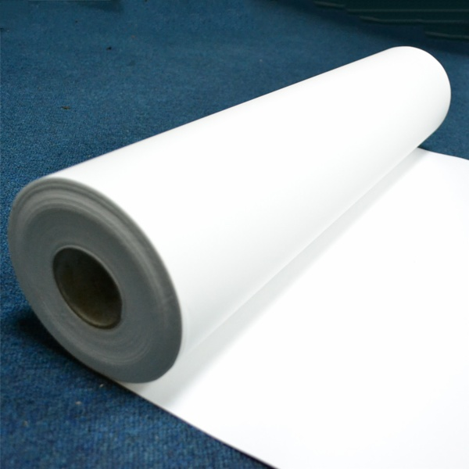

Advantages:
Extremely fast drying
Excellent line sharpness
Superb and quick transfer properties
Outstanding lay-flat performance
Exceptional quality consistency
Out-standing lay-flat performance
No colour strike-through

Tips for Best Results:
1. It is not suitable to transfer the dark garments and ceramic...
2. It can be used to transfer 100% polyester fabric, coating ceramic, iron plant and wood.
3. Do keep the surface of the object clear
4. Do not operate with the laser printer and the printer in pigment ink, like HP and CANNON printer.
5. It must use the sublimation ink.
6. The best transferring time is 10-15 minutes after printing
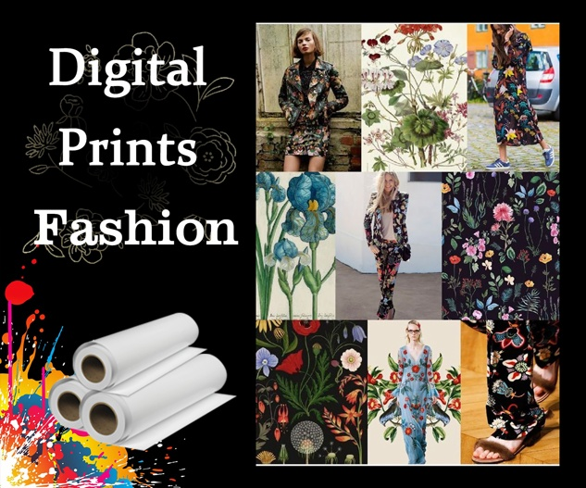

Application :
Transfer on all kinds of polyester textile.

*Apparel:
1.Lycra materials-cycling
2.Polyamide-Swim&Surfwear
3.100% polyester(stretch)-cycling, running, ice hockey wear
4.Sports and functional textiles

*Home Internal:
Curtain, Blind, Cushion, Table Cover, Towel Cleaner, etc.

*Advertisement:
Flags, Banners, Felts, Gaming tables, Soft Signage etc.

OEM:
We accept the oem, you only need give us your design:
1). Put your LOGO on the pack side of the paper.
2). Provide the package ( OPP and box) with your brand.
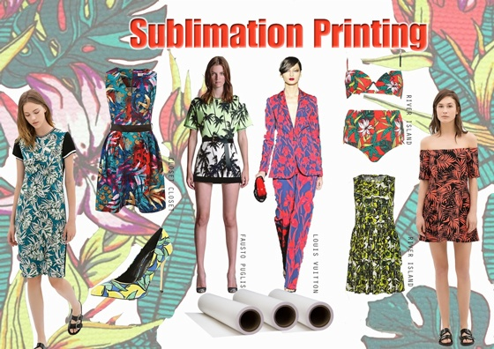

Indoor Condition in Printing Room or Workshop:
Humidity: 40-60% (not more than 60%)
Temperature: 78.8℉ / 26℃

Testing Condition:
Ink-load: 300%
Transfer Temperature: 200-230℃
Transfer Time: 20-30 seconds

About storage:
In order to protect unused sublimation paper, it is recommended to store it in its original packaging, in the poly bag at 68°F -82°F( 20°C -28°C) and 40-60% RH.

About printing:
Image side is wound to the outside of the paper. Printing is performed in ″mirror″ image. Allow the printing ink to dry before transferring.

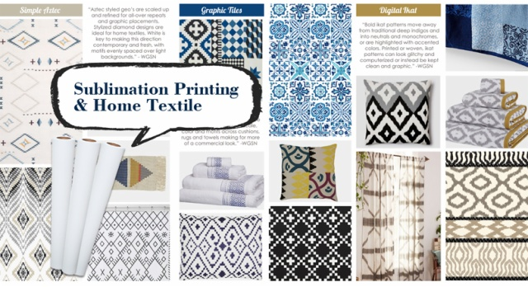

Available Size:

Width | Length | Core | Qty Rolls/Pallet
432mm/17inch | 100m/328ft/109yds | 2inch/3inch | 168
610mm/24inch | 100m/328ft/109yds | 2inch/3inch | 120
914mm/36inch | 100m/328ft/109yds | 2inch/3inch | 88
1,118mm/44inch | 100m/328ft/109yds | 2inch/3inch | 64
1,270mm/50inch | 100m/328ft/109yds | 2inch/3inch | 64
1,320mm/52inch | 100m/328ft/109yds | 2inch/3inch | 64
1,370mm/54inch | 100m/328ft/109yds | 2inch/3inch | 64
1,524mm/60inch | 100m/328ft/109yds | 2inch/3inch | 64
1,600mm/63inch | 100m/328ft/109yds | 2inch/3inch | 64
1,620mm/64inch | 100m/328ft/109yds | 2inch/3inch | 64
1,820mm/72inch | 100m/328ft/109yds | 2inch/3inch | 64
1,900mm/74inch | 100m/328ft/109yds | 2inch/3inch | 64
2,400mm/94inch | 100m/328ft/109yds | 2inch/3inch | 64
Other widths upto 2.4m and jumbo reel sizes available upon request.

1,What is your time of making samples?
Usually we will take around 3-7 days to make the samples.
2,What is your MOQ?
Our MOQ is 50 rolls sublimation paper
3,What is your delivery time?
The time of delivery is about 10-30 days.
4,What is the loading port?
Ningbo, Shenzhen, Guangzhou and Shanghai are available.
5,What is your payment terms?
We accept T/T, Paypal, Western Union, Moneygram, etc.
6,What is your main products?
Our main products are Sublimation Transfer Paper, T Shirts Transfer Paper, Sublimation Inks and other sublimation Blanks and Equipments.
7, What's the shipping way?
Via DHL, FedEx, EMS, UPS, by air, by sea...etc. As you required.
8,Do you have after-sales service?
Yes. If you have any problems, you can chat online or send email to us.
1. Strict Quality Control: We have over 10 workers cooperating on Quality control both for the original Material and finished Goods. QC before delivery is also what we need for each order.
2. One stop Solution: We offer a wide range of sublimation paper, dye sublimation ink and Blanks. Making you able to source all the items you need.
3. Reasonable Pricing: We run our own coating factory and Heat Press Machine assembling Workshop, thus to offer the most reasonable pricing and give the most profit to our clients.
4. Fast Delivery: We offer one week delivery for most paper orders. And 2-3 weeks production lead time for other sublimation inks.
5. Responsible after sale service: As a responsible company, we never make any exercise for mistakes, clients comes first, any complaint is supposed to be settled in a responsible manner.

