The fragrance is always determining factor for us to pay attention to a ceratin product, so fragrant is first choice for us. Because fragrant rice has classic characteristic that no other rice can have. Rice grain is very fine, it has mild and delicate fragrance brings a pleasant feeling to consumers.
Fragrant white rice recipe-DT8
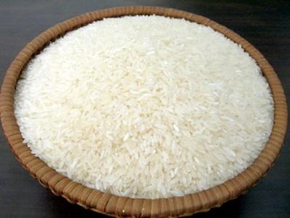
And today, we will recommend to everyone a mild romantic rice variety, that is DT8 rice or also calls Dai Thom 8 rice. I’d like to give everyone detail introduction of the product.
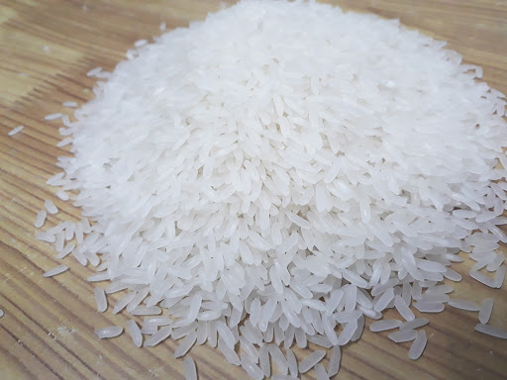
Origins
I will say something about the background.
- DT8 rice has just been grown and developed in VietNam. And it’s most widely grown in Mekong Delta, South Central Coast and Central Highlands.

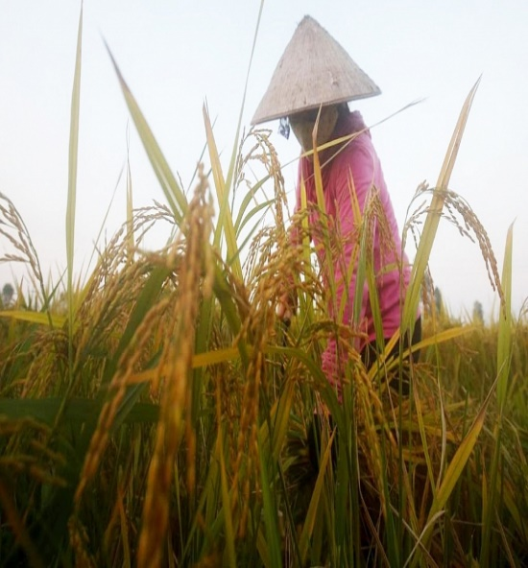
Characteristic
- DT8 rice can drought-tolerant, it has high productive
- And as well as OM5451, DT8 rice has time of growth relatively short and can meet standard export demand.
- When we talking about looks, I believe this grain represents the beauty of all kind of rice because rice grain is very elongated, clear and less white in belly. Amilose content 16,29% look very bull’s eye, attract people.
- When we talk about of quality that can’t be criticized. The rice is very soft and tasty, has a faint smell. And especially, when you to cool, the rice is still very soft, besides the rice is soft but not sticky.
DT8 rice is often used to cook porride for children as it’s easy to eat and fragrant. Maybe people don’t know: This type of rice is also used to make kimbap. In addition, The rice water of DT8 rice has the effect of beautifying skin for women.
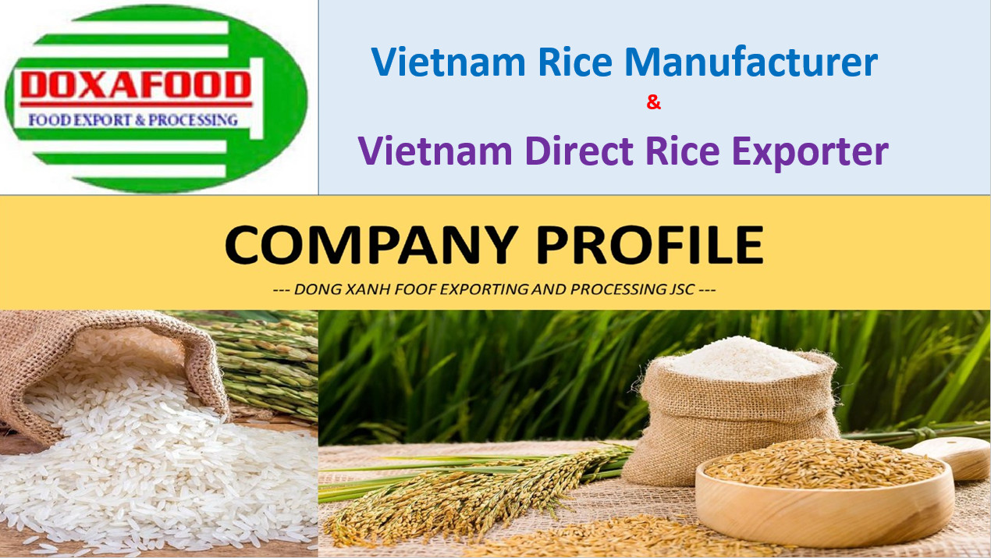
Contact:
DONG XANH FOOD EXPORT AND PROCESSING JOINT STOCK COMPANY
Office Address: Qui Lan 3 Hamlet, Thanh Quoi Commune, Vinh Thanh District, Can Tho City, Viet Nam.
Tel: (84+) 0937231057 (Whatsapp)
Email: Sale2.vinaoneglobal@gmail.com
VIETNAM RICE EXPORTER — DOXAFOOD RICE MILLS:
Doxafood Rice Mills is a rice exporter in Vietnam that can supply/export white rice. We sell Vietnam white rice directly from our ISO 22000:2005 Certified rice mill in Can Tho province of Vietnam. We export Vietnam white rice packed in 25/50 kgs bags, in containers and with free of charge SGS Inspection for quality, quantity and weight at loading port for each shipment.
So, in the heart of the rice-growing region our mill continuously processes the best vietnam white rice for the needs of our customers with reliable quality.

