High Quality 100gsm Regular Sublimation Paper for Transfer Printing

Features:(1. Suit for soft and hard substrates. (2. High transfer rate, superb color, high color reduction degree. (3. Uniform coating, no wet cockling, flying print without wrinkly. (4. Small deformation, clear image and can be save for long times after printed.
Characteristics:
Most widely applied for most of digital sublimation transfer printing. Transfer on all kinds of polyester coated hard substrates and polyester textiles, which is superior quality for digital printing for sportswear, blankets, curtains, wider wall covers, tents, banner, flag, skis and snowboards. For medium to high ink coverage.
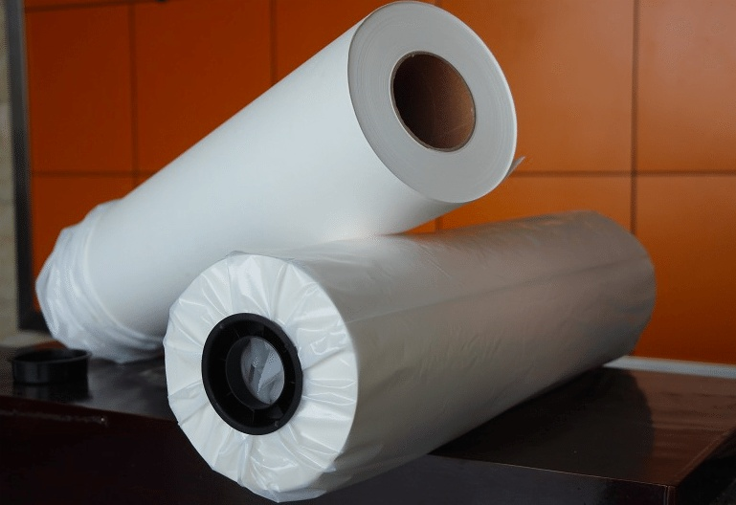

Advantages:
(1. Suit for soft and hard substrates.
(2. High transfer rate, superb color, high color reduction degree.
(3. Dry quickly and good anti-wrap resistance, excellent ink release, absorbing ink speed quickly.
(4. Super transfer efficiency, up to 98%. It is significantly higher than similar products in the market.
(5. Uniform coating, no wet cockling, flying print without wrinkly.
(6. Small deformation, clear image and can be save for long times after printed.
(7. Recommended for designs with dark, saturaed colours or high ink loads
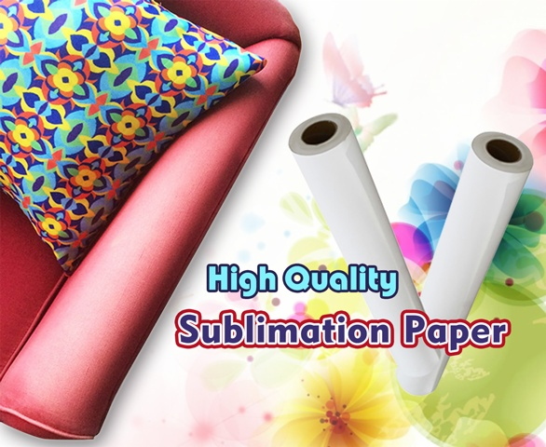

Applications:
*Apparel
- Lycra materials-cycling
- Polyamide-Swim&Surfwear
- 100% polyester(stretch)-cycling, running, ice hockey wear
- Sports and functional textiles
*Home Internal:
Curtain, Blind, Cushion, Table Cover, Towel Cleaner, etc.
*Advertisement
- Flags
- Banners
- Felts
- Gaming tables
- Home Textiles
*Hard Substrates
- Ceramics
- Metal plates
- Skis
- Snowboards
- Mug, Cup

Availablility:
Width | Length | Core | Qty Rolls/Pallet
432mm/17inch | 100m/328ft/109yds | 2inch/3inch | 160
610mm/24inch | 100m/328ft/109yds | 2inch/3inch | 112
914mm/36inch | 100m/328ft/109yds | 2inch/3inch | 80
1,118mm/44inch | 100m/328ft/109yds | 2inch/3inch | 56
1,270mm/50inch | 100m/328ft/109yds | 2inch/3inch | 56
1,320mm/52inch | 100m/328ft/109yds | 2inch/3inch | 56
1,370mm/54inch | 100m/328ft/109yds | 2inch/3inch | 56
1,524mm/60inch | 100m/328ft/109yds | 2inch/3inch | 56
1,600mm/63inch | 100m/328ft/109yds | 2inch/3inch | 56
1,620mm/64inch | 100m/328ft/109yds | 2inch/3inch | 56
1,820mm/72inch | 100m/328ft/109yds | 2inch/3inch | 56
1,900mm/74inch | 100m/328ft/109yds | 2inch/3inch | 56
2,400mm/94inch | 100m/328ft/109yds | 2inch/3inch | 64
2500mm/98inch | 100m/328ft/109yds | 2inch/3inch | 30
2600mm/102inch | 100m/328ft/109yds | 2inch/3inch | 30
3200mm/126inch | 100m/328ft/109yds | 2inch/3inch | 30
Other widths upto 3.2m and jumbo reel sizes available upon request.

About Our Company
We have complete confidence to offer you high quality, to satisfy well with your requirements
1.10 years experience of printer consumables production in China.
2. Top quality material we import from Germany
3. Strict quality controlling and professional QC inspecting before shipping
4. Factory directly supply, all made by ourselves, save much cost for you.
5. High quality and best services
6. OEM/ODM orders are acceptable
1,What is your time of making samples?
Usually we will take around 3-7 days to make the samples.
2,What is your MOQ?
Our MOQ is 50 rolls sublimation paper
3,What is your delivery time?
The time of delivery is about 10-30 days.
4,What is the loading port?
Ningbo, Shenzhen, Guangzhou and Shanghai are available.
5,What is your payment terms?
We accept T/T, Paypal, Western Union, Moneygram, etc.
6,What is your main products?
Our main products are Sublimation Transfer Paper, T Shirts Transfer Paper, Sublimation Inks and other sublimation Blanks and Equipments.
7,What's the shipping way?
Via DHL, FedEx, EMS, UPS, by air, by sea...etc. As you required.
8,Do you have after-sales service?
Yes. If you have any problems, you can chat online or send email to us.
1. Strict Quality Control: We have over 10 workers cooperating on Quality control both for the original Material and finished Goods. QC before delivery is also what we need for each order.
2. One stop Solution: We offer a wide range of sublimation paper, dye sublimation ink and Blanks. Making you able to source all the items you need.
3. Reasonable Pricing: We run our own coating factory and Heat Press Machine assembling Workshop, thus to offer the most reasonable pricing and give the most profit to our clients.
4. Fast Delivery: We offer one week delivery for most paper orders. And 2-3 weeks production lead time for other sublimation inks.
5. Responsible after sale service: As a responsible company, we never make any exercise for mistakes, clients comes first, any complaint is supposed to be settled in a responsible manner.

